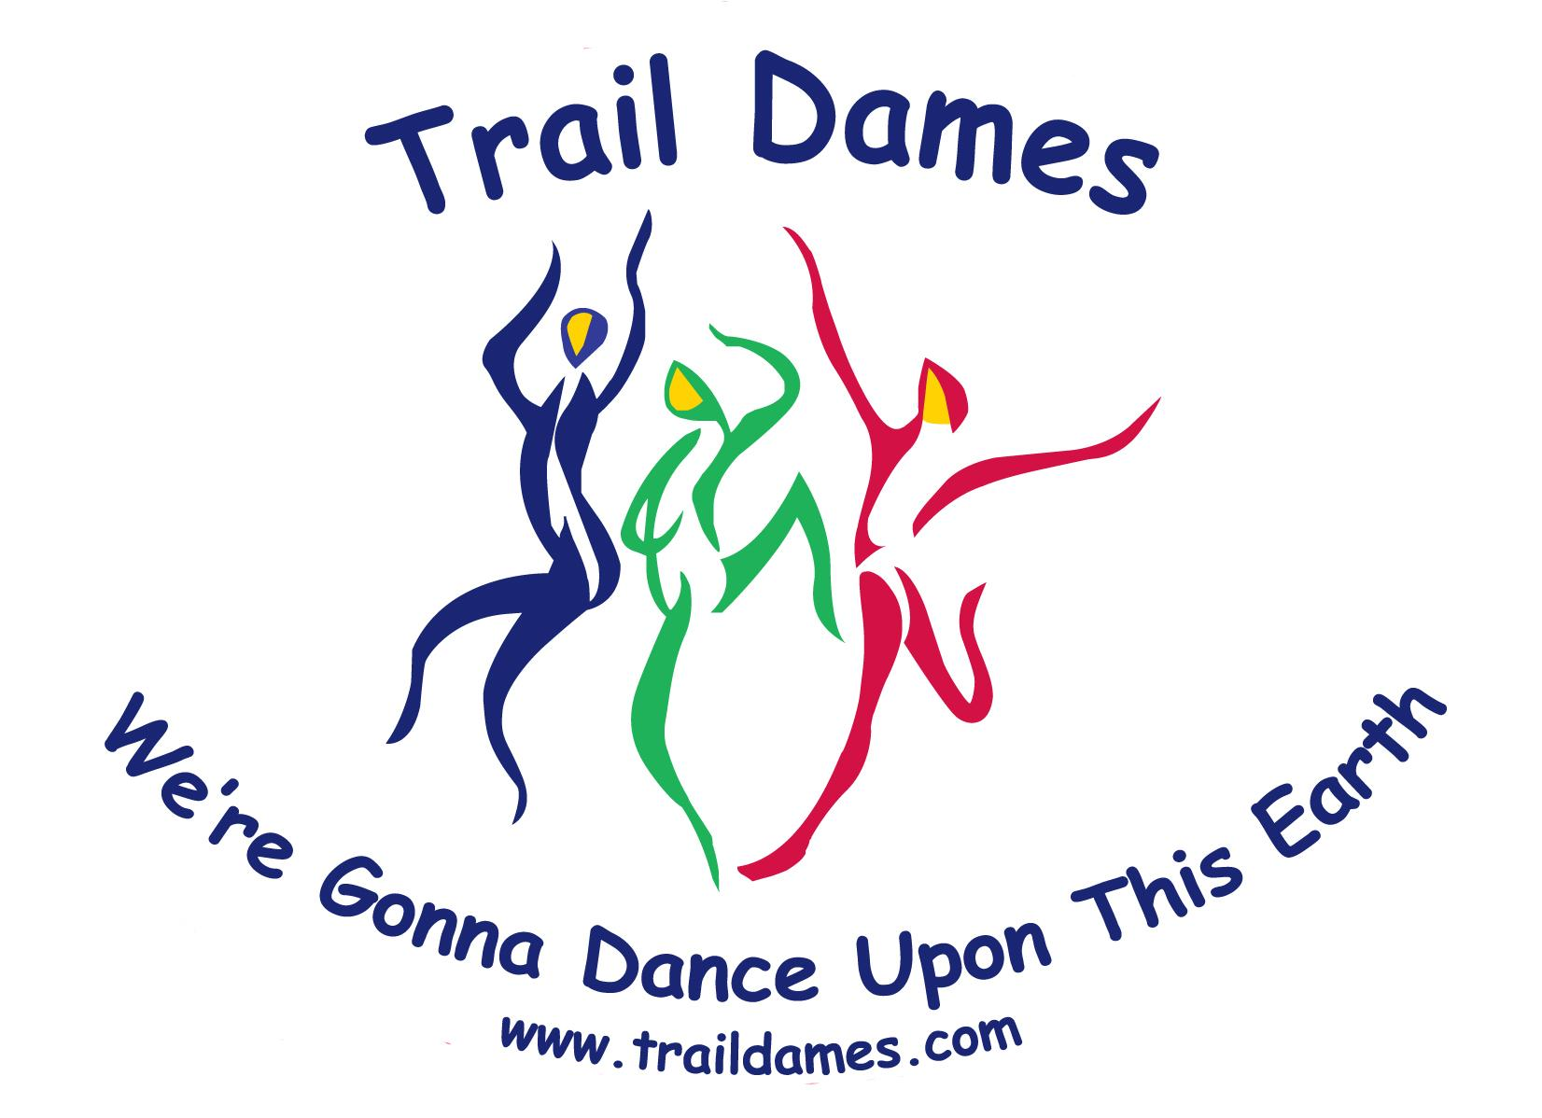
Trail Dames Event Waiver

I understand that during my participation in this Trail Dames event, I may be exposed to a variety of hazards and risks, foreseen or unforeseen, which are inherent in each event and cannot be eliminated. I understand that risks of such Injuries and Damages are involved in adventure travel such as Trail Dames events and I appreciate that I may have to exercise extra care for my own person and for others around me in the face of such hazards. I further understand that on this event there may not be rescue or medical facilities or expertise necessary to deal with the Injuries and Damages to which I may be exposed.

In consideration of my acceptance as a participant in this event, and the services and amenities to be provided by Trail Dames in connection with the event, I confirm my understanding that:

• I have read the rules and conditions applicable to the event made available to me; I will pay any costs and fees for the event; and I acknowledge my participation is at the discretion of the leader.

• The event officially begins and ends at the location(s) designated by Trail Dames. The event does not include carpooling, transportation, or transit to and from the event, and I am personally responsible for all risks associated with travel. This does not apply to transportation provided by Trail Dames during the event.

• I have willingly disclosed any medical condition that I have, medications that I am taking, and/or allergies that might affect my experience during the event.

• If I decide to leave early and not complete the event as planned, I assume all risks inherent in my decision to leave and waive all liability against Trail Dames arising from that decision. Likewise, if the leader has concluded the event, and I decide to go forward without the leader, I assume all risks inherent in my decision to go forward and waive all liability against Trail Dames arising from that decision.

• I also hereby grant Trail Dames, Inc. permission to use my likeness in photograph(s)/video in any and all of its publications and in any and all other media, whether now known or hereafter existing, controlled by Trail Dames, in perpetuity, and for other use by Trail Dames. I will make no monetary or other claim against Trail Dames for the use of the photograph(s)/video.
• This Agreement is intended to be as broad and inclusive as is permitted by law. If any provision or any part of any provision of this Agreement is held to be invalid or legally unenforceable for any reason, the remainder of this Agreement shall not be affected thereby and shall remain valid and fully enforceable.

• To the fullest extent allowed by law, I agree to WAIVE, DISCHARGE CLAIMS, AND RELEASE FROM LIABILITY Trail Dames, its officers, directors, employees, agents, and leaders from any and all liability on account of, or in any way resulting from Injuries and Damages, even if caused by negligence of Trail Dames its officers, directors, employees, agents, and leaders, in any way connected with this event. I further agree to HOLD HARMLESS Trail Dames, its officers, directors, employees, agents, and leaders from any claims, damages, injuries, or losses caused by my own negligence while a participant in the event. I understand and intend that this assumption of risk and release is binding upon my heirs, executors, administrators, and assigns, and includes any minors accompanying me on the event.

• I have read this document in its entirety and I freely and voluntarily assume all risks of such Injuries and Damages and notwithstanding such risks, I agree to participate in the event.

Name: _______________________________________ (print name)
Address: __________________________________________
__________________________________________
_____________________
Phone: ________________________________
Email: _________________________________

Emergency Contact Information
Name: _______________________________________
Phone: ________________________________
Relationship: ___________________________

Known medical issues: ____________________________________________________________________________________________________________________________________________________________________
Medication Allergies: ________________________________________________________________

Signature: _______________________________________________ Date: _____________________

Board Approved: March 2015

